
PM Formalisation of
Micro Food Processing Enterprises Scheme

HANDBOOK OF
ONION PASTE PROCESSING

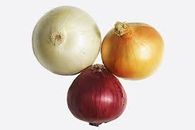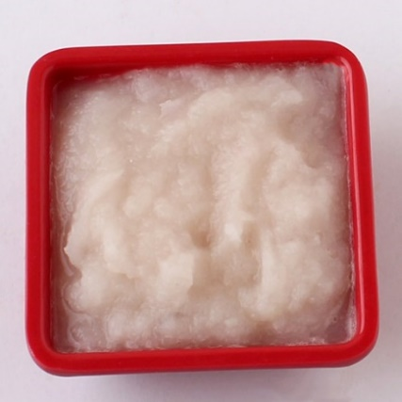

AATMANIRBHAR BHARAT
Indian Institute of Food Processing Technology
Ministry of Food Processing Industries
Pudukkottai Road, Thanjavur, Tamil Nadu 613005
Website: http://www.iifpt.edu.in
Email: info@iifpt.edu.in
Call: +91 4362 228155

TABLE OF CONTENTS
Page No.
Chapter 1: Introduction
1.1 |  | About Onion | 3-4
1.2 |  | Market Status | 4-5
1.3 |  | Health Benefits | 6-8
1.4 |  | Value Addition | 8-9
1.5 |  | Onion Paste | 9
Chapter 2: Processing of Onion Paste

2.1 |  | Ingredients used | 10
2.2 |  | Processing | 10-12
2.3 |  | Flow Chart | 13
2.4 |  | Machines used | 14-16
Chapter 3: Packaging
3.1 |  | Source of Contamination | 17
3.2 |  | Criteria for packaging material | 17
3.3 |  | Major Classification of Packaging | 17-21
Chapter 4: FSSAI Food Regulations and Standards
4.1 | Definition of Standards |  | 22
4.2 | Packaging and Labelling regulations |  | 22-27
4.3 | Sanitary and hygiene requirements |  | 27-28

CHAPTER 1
INTRODUCTION
  - ABOUT
Onion, (Allium cepa), herbaceous biennial plant in the amaryllis family (Amaryllidaceae), grown for its edible bulb. The onion is likely native to southwestern Asia but is now grown throughout the world, chiefly in the temperate zones. They are valued for their flavour and are used widely in cooking. They add flavour to such dishes as stews, roasts, soups, and salads and are also served as a cooked vegetable. Onions are best cultivated in fertile soils that are well-drained. Sandy loams are good as they are low in sulphur, while clayey soils usually have a high sulphur content and produce pungent bulbs. Onions require a high level of nutrients in the soil.
Onions differ in the size, colour and taste. Spring onions are grown in warmer climates and have a milder, sweeter taste. Storage onions are grown in colder weather climates and generally have a more pungent flavour and are usually named by their colour: white, yellow or red. Smaller onions come in many types, such as chives, leeks and shallots.
In India, it is grown as major bulb crop. Both immature and mature bulbs are used as vegetable and condiment. Onions not only provide flavour; they also provide important nutrients and health-promoting phytochemicals. It contains vitamin B and a trace of vitamin C and also traces of iron and calcium. As a culinary ingredient it adds to the taste and flavour in a wide range of food preparations and it is also used as a salad. Thus, there is a steady increase in the demand for onion across the world.
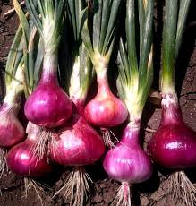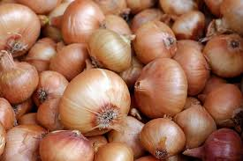
Varieties in India:
The major varieties found in India are Agrifound Dark Red, Agrifound Light Red, NHRDF Red, Agrifound White, Agrifound Rose and Agrifound Red, Pusa Ratnar, Pusa Red, Pusa White Round. There are certain varieties in yellow onion which are suitable for export in European countries Tana F1, Arad-H, Suprex, Granex 55, HA 60 and Granex 429.

1.2 MARKET STATUS

World Scenario

About 170 countries of the world cultivate onions for domestic use while some also grow onions for trade. About 9.2 million acres of onions are harvested each year on a global scale and 8% of this harvest is internationally traded. China, India, and the US are the world’s leading onion producing countries.

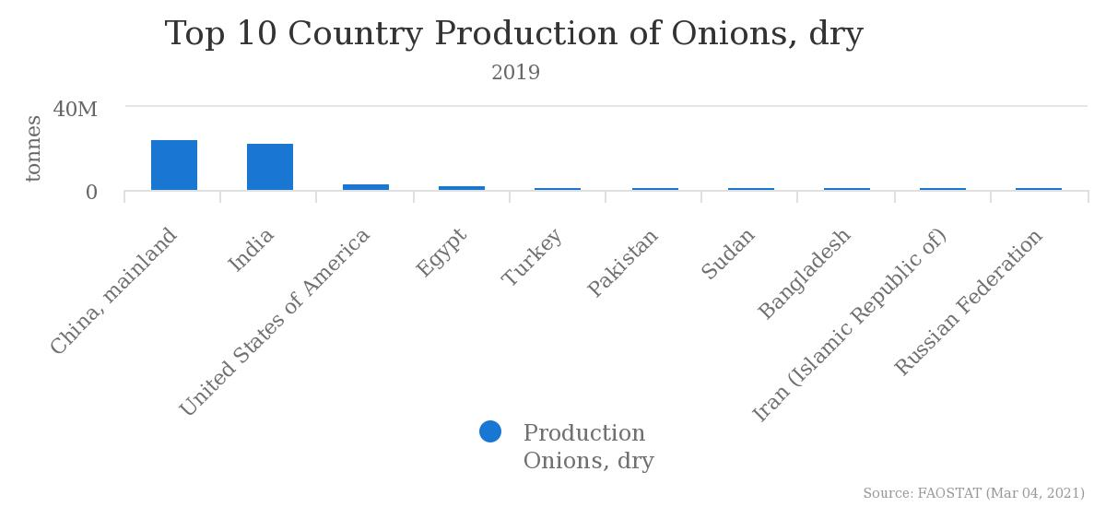

(Source: FAOSTAT)
Indian Scenario
Total production of Onions, dry in India in year 2019 was 22819000 tonnes (Source: NHB). The major Onion producing states are Maharashtra, Madhya Pradesh, Karnataka, Rajasthan, Bihar, Gujarat, Andhra Pradesh, Haryana, West Bengal and Uttar Pradesh in the country. These States account for almost 90% of the total Onion production in the country.
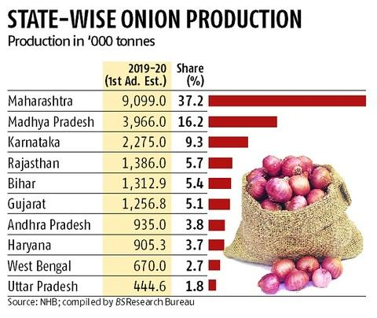

ONION | 2018-19 |  | 2019-20 (1st Advance Estimate) |  | 2019-20 (2nd Advance Estimate)
ONION | Area  (in ‘000 Ha) | Production  '000 MT | Area  (in ‘000 Ha) | Production  '000 MT | Area  (in ‘000 Ha) | Production  '000 MT
ONION | 1220 | 22819 | 1293 | 24454 | 1434 | 26738
(Source: National Horticulture Board)
Export
There is a lot of demand of Indian Onion in the world, the country has exported 11,49,896.85 MT of fresh onion to the world for the worth of Rs. 2,320.70 crores/ 324.20 USD Millions during the year 2019-20.
Major Export Destinations (2019-20): Bangladesh, Malaysia, UAE, Sri Lanka, Nepal.
(Source: APEDA)

1.3 HEALTH BENEFITS
- Packed with Nutrients
Onions are nutrient-dense, meaning they’re low in calories but high in vitamins and minerals. It is particularly high in vitamin C, a nutrient involved in regulating immune health, collagen production, tissue repair and iron absorption. Vitamin C also acts as a powerful antioxidant in your body, protecting your cells against damage caused by unstable molecules called free radicals. Onions are also rich in B vitamins, including folate (B9) and pyridoxine (B6) ,which play key roles in metabolism, red blood cell production and nerve function. They’re a good source of potassium.
- May Benefit Heart Health

Onions contain antioxidants and compounds that fight inflammation, decrease triglycerides and reduce cholesterol levels, all of which may lower heart disease risk. Their potent anti-inflammatory properties may also help reduce high blood pressure and protect against blood clots. Quercetin is a flavonoid antioxidant that’s highly concentrated in onions. Since it’s a potent anti-inflammatory, it may help decrease heart disease risk factors, such as high blood pressure.
- Loaded with Antioxidants
Antioxidants are compounds that inhibit oxidation, a process that leads to cellular damage and contributes to diseases like cancer, diabetes and heart disease. Onions are an excellent source of antioxidants. In fact, they contain over 25 different varieties of flavonoid antioxidants. Red onions, in particular, contain anthocyanins, special plant pigments in the flavonoid family that give red onions their deep colour. Multiple population studies have found that people who consume more foods rich in anthocyanins have a reduced risk of heart disease.
- Contain Cancer-Fighting Compounds
Eating vegetables of the Allium genus like garlic and onions has been linked to a lower risk of certain cancers, including stomach and colorectal. These cancer-fighting properties have been linked to the sulphur compounds and flavonoid antioxidants found in allium vegetables. Thus, a diet rich in allium vegetables like onions may have a protective effect against certain cancers.

Help Control Blood Sugar
Eating onions may help control blood sugar, which is especially significant for people with diabetes or prediabetes. Additionally, multiple animal studies have shown that onion consumption may benefit blood sugar control. Specific compounds found in onions, such as quercetin and sulphur compounds, possess antidiabetic effects.

May Boost Bone Density
Though dairy gets much of the credit for boosting bone health, many other foods, including onions, may help support strong bones. Another study in 507 perimenopausal and postmenopausal women found that those who ate onions at least once a day had a 5% greater overall bone density than individuals who ate them once a month or less. Plus, the study demonstrated that older women who most frequently ate onions decreased their risk of hip fracture by more than 20% compared to those who never ate them.

Have Antibacterial Properties
Onions can fight potentially dangerous bacteria, such as Escherichia coli (E. coli), Pseudomonas aeruginosa, Staphylococcus aureus (S. aureus) and Bacillus cereus. Furthermore, onion extract has been shown to inhibit the growth of Vibrio cholerae, a bacterium that is a major public health concern in the developing world. Quercetin extracted from onions seems to be a particularly powerful way to fight bacteria.

May Boost Digestive Health
Onions are a rich source of fibre and prebiotics, which are necessary for optimal gut health. Prebiotics are nondigestible types of fibre that are broken down by beneficial gut bacteria. Gut bacteria feed on prebiotics and create short-chain fatty acids — including acetate, propionate and butyrate. Research has shown that these short-chain fatty acids strengthen gut health, boost immunity, reduce inflammation and enhance digestion. A diet rich in prebiotics may help improve the absorption of important minerals like calcium, which may improve bone health. Onions are particularly rich in the prebiotic inulin and fructooligosaccharides. These helps increase the number of friendly bacteria in the gut and improve immune function.
Nutritional content
Sl. No. | Nutrient | Amount(/100g)
 | Energy | 40 kcal
 | Protein | 1.1 gm
 | Fibre, total dietary | 1.7 gm
 | Carbohydrate | 9.34 gm
 | Total lipid (fat) | 0.1 gm
 | Sugars | 4.24 gm
 | Vitamin C, total ascorbic acid | 7.4 mg
 | Calcium | 23 mg
 | Magnesium | 10 mg
 | Potassium | 146 mg
(Source: USDA)
1.4 VALUE ADDITION
Onion offers a huge potential for value creation through processing. Advances in the field of processing makes it possible to produce different value-added products from onion i.e minimally processed ready to use or ready to cook fresh onion, onion paste, dehydrated onion flakes, onion powder, onion oil, onion vinegar, onion sauce, pickled onion, onion wine and beverages etc.
Minimally processed onions are peeled and/or cut onions which retain its freshness. Availability of minimally processed onions to cook or ready to use purpose reduces the overall food preparation time. Alternatively, onions are used by way of frozen onion rings where the raw onions are sliced into rings, freeze dried and stored in a suitable packaging material under low temperatures. The frozen onion rings have a long storage life of 12 months and can be readily used for direct consumptions or for adding to soups and dressings.
Onion paste is another product where the onion is grounded yet retaining its freshness. Dehydrated onion flakes can be processed into onion powder by proper grinding. Onion powder dissolves very easily and reconstitute quickly compared to onion flakes. It is successfully used in the preparation of baked products like pizza and bread, and also for spicing up grilled chicken. Onion oil is another flavouring substance which is widely used in the seasoning of processed products and is also used as a natural used preservative in some food products. Onion salt is another common ingredient in the spice mix and can be used at the place of table salt to offer a refreshing new taste to the household.
1.5 ONION PASTE
Onions can be processed into ready-to-use onion puree and paste which can be stored for more than six months under refrigeration condition. It can be made with either boiled or fried onions and can be instantly used for quick preparation of gravy, as base for many curry preparations and for flavouring. This product provide convenience to the consumers by restricting the kitchen drudgery and time involved in the preparation of the product. Onion paste and puree can be utilised in the preparation of curried vegetarian and non-vegetarian dishes.
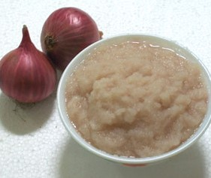

CHAPTER 2
PROCESSING
  - INGREDIENTS USED
- Raw Onion
- Salt- 2-5%
- Citric acid-0.1 %- 0.2%
  - PROCESSING
- Grading and Sorting
The onions are separated into two or more grades on the basis of the surface colour, shape, size, weight, soundness, firmness, cleanliness, maturity & free from foreign matter /diseases insect damage /mechanical injury. Grading may be done manually or mechanically. Sorting is also done by hand or machine to remove the onions which are unsuitable for processing due to mechanical injuries, insects, diseases, immature, over-mature, misshapen etc. By removing damaged produce from the healthy ones, it reduces losses by preventing secondary contamination.
- Cutting roots and stems
Harvested onions have long leaves on the top side of the onion body, and it is necessary to cut the leaves and base of the onions which has roots so as to get clean onion bulbs. Conventionally, it was done manually. Now a days, machines can be used to trim the stems and roots of the onions, saving time and labour.
- Peeling
Peeling is one of the integral parts of a food processing, and the onions are need to be peeled in order to remove the inedible portion at the initial stage of processing Currently peeling is carried out by various methods which is including manual peeling (knife or blade) or mechanical peeling (abrasive devices, devices with drums, knifes or blades etc). Mechanical peeling includes different types of process that interact with directly skin and then removes the skin.
- Washing
Thorough washing by jet spray is done to remove leftover peel, dust, dirt from onions before crushing them into paste.
- Pulping
The washed onions are then made into paste. Crushing machine is used to crush the onion first. It is then put to pulping machine to obtain a paste of uniform consistency. Automatic onion grinding machine can be used for fine semi moist puree and paste.
- Heating
Fresh onion paste contains around 84% moisture. In order to reduce the moisture content and to make an onion paste concentration, it is heated at 110 degree Celsius in an open steel vessel / a steam kettle. The pulp is concentrated till 32⁰ Brix is obtained on hand refractometer. 2 % salt is added for taste and 0.1% citric acid is added for preservation purpose.
- Pasteurization
Preservation of culinary paste by application of heat is the most common method. Pasteurization is a process in which paste/puree is heated to 82⁰C or slightly below for a sufficient time to inactivate/kill the micro-organisms, which cause spoilage. Usually, time ranges from 30 sec to 30 min depending on the type of heating system, the nature of paste and the size of the container.
- Filling
To prevent contamination, the onion paste passes from the receiving tanks to the filling machines at a temperature not lower than 75°C - 80°C. The containers are filled with the paste and immediately sealed to retain the freshness of the product. Onion paste’ containers come in various sizes and shapes, including bottles, cans, pouch packs etc.
- Cooling and Storage
The containers must be cooled to prevent flavour loss through stack burning, which occurs when paste stays at high temperatures after cooking is complete. Containers of onion paste may be cooled in cold air or cold water. After cooling, proper storage must be done.

  - FLOW CHART
Raw onion, dry
2.4 MACHINES USED
Cooling and Storage
Pulping
Filling @ 75°C - 80°C
Heating @ 110 degree Celsius (Addition of salt-2%, Citric acid-0.1 %)
Pasteurization (82℃)
Washing
Cutting (Stems and roots)
Peeling
Grading and Sorting
- Industrial bubble washing machine
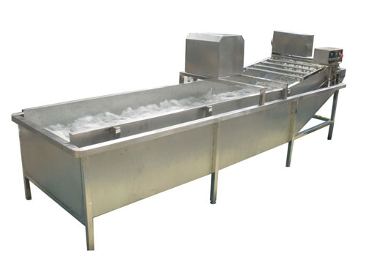

To remove adhering dirt, to remove latex strains, to remove surface organism if any, wash with 50 ppm chlorine to prevent the microbial contamination
- Onion Peeling Machine
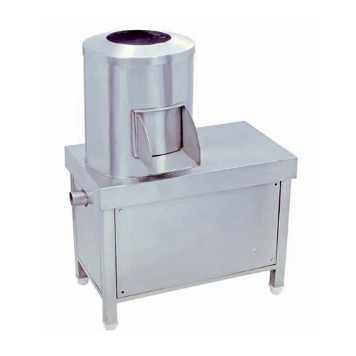
This machine is regarded for its high tensile strength and resistance to corrosion. It is durable, seamless in terms of finish and resistant to corrosion. This machine is used for peeling onion in restaurants and food processing industry.
- Onion Grinding Machine
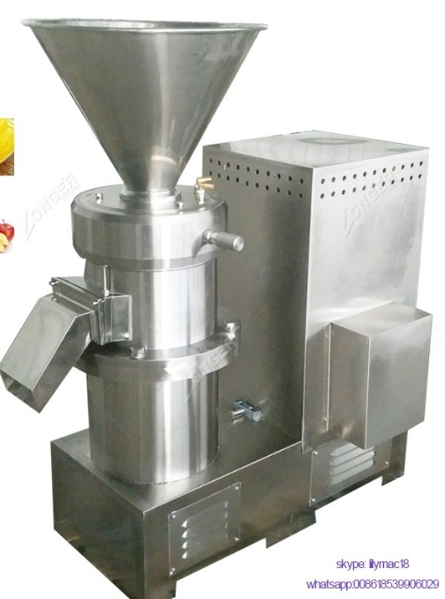
It can grind root vegetable like the fresh or bloated onion etc. into paste. Thickness of the paste can be adjusted.
- Electric heating Jacketed Kettle
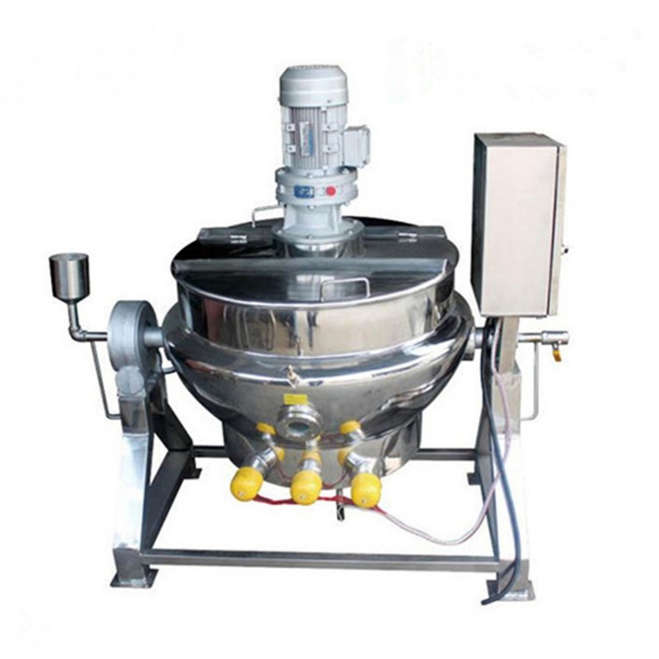
It is used to heat the Onion Paste. Its thick steel material strong enough to hold the body stable without shaking while mixing with max speed. Heating temperature is easily monitored and controlled on the panel.
- Pasteurizer
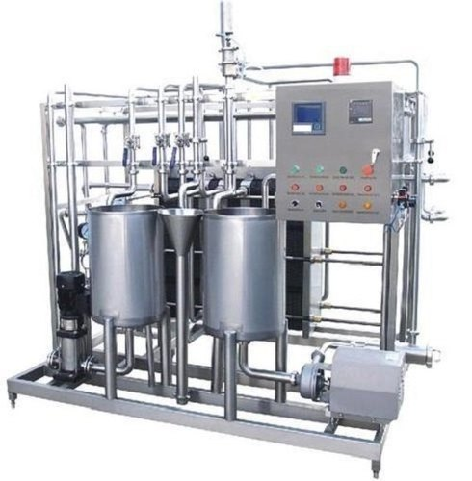
The sterilization temperature can be adjusted from 62℃ to 85℃ for 1 minute. It can eliminate bacteria, yeast and inhibit enzyme activity in paste/puree.

- Packaging machine
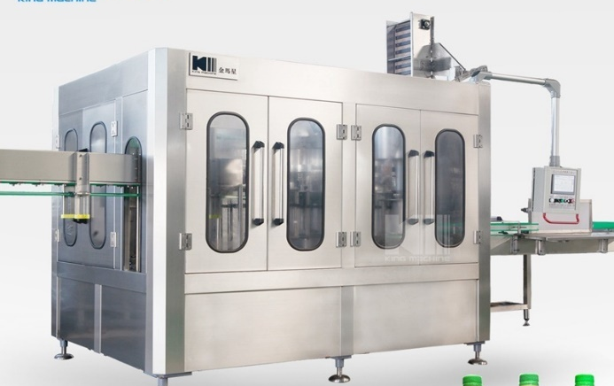

For bottling filling and sealing, pouch packaging.

CHAPTER 3
PACKAGING
3.1. SOURCE OF CONTAMINATION

The major source of sauce contamination is micro-organisms. The microbial load on the product before and after storage should, therefore, be carefully studied in order to avoid deterioration of product. Bacterial flora, fungal growth and yeast are some of the microorganisms frequently observed in packed sauces. As it is containing citric acid, onion paste does not spoil easily. In order to maintain the product’s quality more effectively, it is suggested that sauces (and any other processed food) be refrigerated after opening because refrigeration retards spoilage.
  - CRITERIA FOR PACKAGING MATERIAL

Packaging enhances the life span of many perishable food items. The package should offer sufficient barrier against light, moisture, gases, and other environmental factors. Apart from this, it should also protect the organoleptic characteristics (quality attributes) of sauces viz. colour, flavour, taste and overall acceptability. The package should prevent emission of off-flavours. The package must be “chemically clean and inert”, and it should be able to perform at high processing speeds. In order to protect leaching out of powerful flavour ingredients through film structures thereby causing de-lamination, chemical resistant adhesives and primers can be used to assure packaging integrity.
  - MAJOR CLASSIFICATION OF PACKAGING FOR ONION PASTE
Primary packing
Secondary packing
Tertiary packing
Primary Packing – is the material that first envelops the product and hold it. This Usually is the smallest unit of distribution or use and is the package which is in direct contact with the contents. For Onion paste, primary packaging available in the market are:
- Glass Jars
Bottles/ jars are commonly used for paste/puree and sauce. Glass bottles of various sizes are used and shapes with labels and provided with metal or plastic caps. The glass used for food packaging is soda-lime glass. Most bottles and jars are tailor-made specifically for one product or one manufacturer. Glass containers can be reused or recycled. It eliminates the risk of potentially harmful chemicals found in some plastics that can leach into food. It is now slowly being replaced because of the disadvantages such as heavy weight and brittleness.
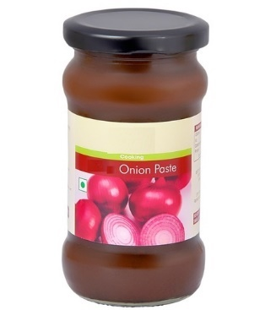

- Stand up Pouches
Introduction of stand-up pouch for paste/puree packing is one of the innovations in the packaging field. This type of packing was designed with the objective to provide a cost effective and consumer friendly alternative to lay flat pouches with easy-pour-out and re-closing facilities. Generally, stand-up pouch is made up of 6 colour reverse printed laminate structure of a 10µ PET / 120µ-3 layer PE film, structurally providing the pack contents with physical, chemical and biological protection. Some important features of the stand-up pouch are:
- Value addition through packing
- An easy-to-use pack, which incorporates easy pourability and re-closing in its design
- Unique stand-up format providing greater display capabilities and brand imaging
- Automatic packing
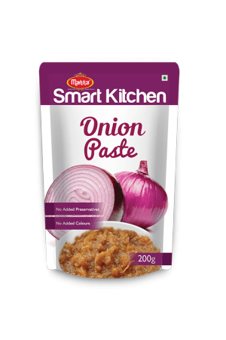
- Plastic bottles (PET bottles)
PET is clear, tough, and has good gas and moisture barrier properties. Most companies opt for an oval shaped bottle with large mouth for easy dispensing of paste. Its advantages are:
- Clear, shiny and transparent.
- Good barrier properties.
- 100% recyclable.
- Clear and optically smooth surfaces for oriented films and bottles
- Excellent barrier to oxygen, water, and carbon dioxide
- High impact capability and shatter resistance
- Excellent resistance to most solvents

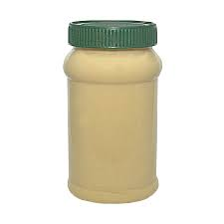
- Metal Can
Steel and aluminium are used for metal container and closure construction for vegetable products like onion paste. Both are relatively low-cost materials that are non-toxic, having adequate strength and are capable of being work hardened. It has following advantages:
- Preserve and protect the product
- Resist chemical actions of the product
- Withstand the handling and processing conditions
- Withstand the external environment conditions
- Have the required shelf display properties at the point of sale
- Give easy opening and simple/safe product removal
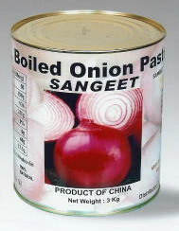
- Polypropylene (PP) Cups
PP has good chemical resistance, is strong, and has a high melting point making it good for hot-fill liquids. This resin is found in flexible and rigid packaging, fibres, and large moulded parts for automotive and consumer products. Some of its advantages are:-
- Excellent optical clarity in biaxially oriented films and stretch blow moulded containers
- Low moisture vapor transmission
- Inertness toward acids, alkalis, and most solvents
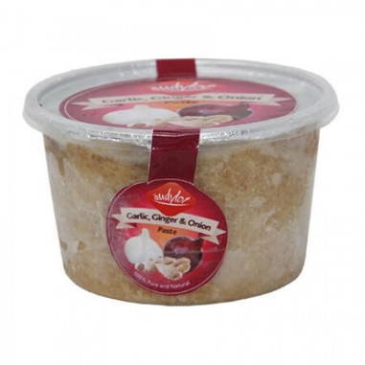

Secondary Packaging
Secondary packaging is used mainly for logistical and storage purposes, to protect and collect individual units. Sometimes is also referred to as grouped or display packaging as they are made to display multiple units of products for sale. This facilitates resupply from the warehouse to the store and includes shelf-ready packaging (SRP), retail-ready packaging (RRP) or counter display units (CDU).
Secondary Packing Available for Onion paste in market
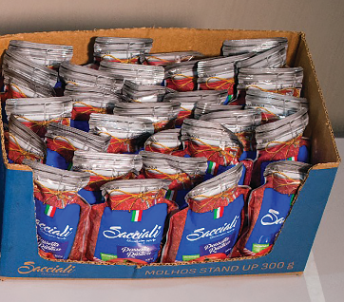
  - Paper boards
  - Cartons
  - Reusable Plastic Crates

Tertiary packaging
Tertiary packaging is typically not seen by consumers since it is usually removed by retailers before products are displayed for sale. It is one of the three types of wrapping used to protect manufactured goods for shipping or storing. It is used to protect not only the product but also its secondary and primary packaging.
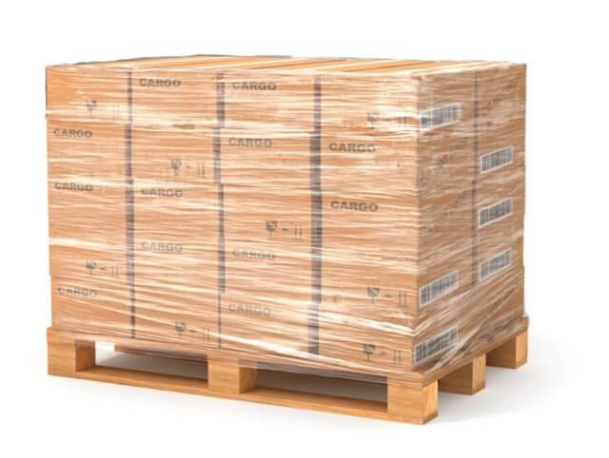

•Used for handling of bulk during storage and transport.
• Carton palletized unit of secondary package. Package for any product is selected based on their characteristics and stability
CHAPTER 4
FOOD SAFETY REGULATIONS AND STANDARDS

4.1 DEFINITION OF STANDARDS - (FOOD PRODUCTS STANDARDS AND FOOD ADDITIVES. REGULATIONS, 2011)
According to FSSAI Standards (Food Products Standards and Food Additives) Regulations, 2011) 2.3.28 Culinary Pastes / Fruits and Vegetable Sauces Other Than Tomato Sauce and Soya Sauce
1. Culinary Pastes / Fruits and Vegetable Sauces Other Than Tomato Sauce and Soya Sauce means a culinary preparation used as an adjunct to food, prepared from edible portion of any suitable fruit/vegetable including, roots, tubers & rhizomes, their pulps/purees, dried fruits, singly or in combination by blending with nutritive sweeteners, salt, spices and condiments and other ingredient appropriate to the product.
2. It may contain caramel but shall not contain any other added colour whether natural or synthetic. The product shall conform to the microbiological requirements given in Appendix B. It shall meet the following requirements: -
Name of the Product | Total Soluble Solids  (Salt free basis) (m/m) | Acidity % (as acetic acid)
Sauces/ Culinary Paste | Not less than 15.0 percent | Not less than 1.2 percent

3. The container shall be well filled with the product and shall occupy not less than 90 percent of the water capacity of the container, when packed in the rigid containers. The water capacity of the container is the volume of distilled water at 20ºC which the sealed container is capable of holding when completely filled.

4.2 FOOD SAFETY AND STANDARDS (PACKAGING AND LABELLING) REGULATIONS, 2011
FSSAI 2.1: Packaging 2.1.1: General Requirements
1. A utensil or container made of the following materials or metals, when used in the preparation, packaging and storing of food shall be deemed to render it unfit for human consumption:— (a) containers which are rusty; (b) enamelled containers which have become chipped and rusty; (c) copper or brass containers which are not properly tinned (d) containers made of aluminium not conforming in chemical composition to IS:20 specification for Cast Aluminium & Aluminium Alloy for utensils or IS:21 specification for Wrought Aluminium and Aluminium Alloy for utensils.
2. Containers made of plastic materials should conform to the following Indian Standards Specification, used as appliances or receptacles for packing or storing whether partly or wholly, food articles namely: —
(i) IS: 10146 (Specification for Polyethylene in contact with foodstuffs);
(ii) IS: 10142 (Specification for Styrene Polymers in contact with foodstuffs);
(iii) IS: 10151 (Specification for Polyvinyl Chloride (PVC), in contact with foodstuffs);
(iv) IS: 10910 (Specification for Polypropylene in contact with foodstuffs);
(v) IS: 11434 (Specification for Ionomer Resins in contact with foodstuffs);
(vi) IS: 11704 Specification for Ethylene Acrylic Acid (EAA) copolymer.
(vii) IS: 12252 - Specification for Poly alkylene terephathalates (PET).
(viii) IS: 12247 - Specification for Nylon 6 Polymer;
(ix) IS: 13601 - Ethylene Vinyl Acetate (EVA);
(x) IS: 13576 - Ethylene Metha Acrylic Acid (EMAA);
(xi) Tin and plastic containers once used, shall not be re-used for packaging of edible oils and fats; Provided that utensils or containers made of copper though not properly tinned, may be used for the preparation of sugar confectionery or essential oils and mere use of such utensils or containers shall not be deemed to render sugar confectionery or essential oils unfit for human consumption.

Labelling Requirements
All food products sold in India that are pre-packaged are required to comply with the Food Safety and Standards (Packaging and labelling) Regulations, 2011. The Food Safety and Standards Regulation, 2011 is a notification issued by the Food Safety and Standards Authority of India under the Ministry of Health and Family Welfare.

Applicability of Food Labelling Regulations
The food labelling regulations require all “Pre-packaged” or “Pre-packed food” to comply with the labelling regulations in India. As per the rules, pre-packaged food means food, which is placed in a package of any nature, in such a manner that the contents cannot be changed without tampering it and which is ready for sale to the consumer.

General Labelling Requirements
The following labelling requirements must be complied with by all pre-packaged food sold in India:
- The label must be in English or Hindi or Devnagri language. In addition to the above, the label can contain information in any other language, as required.
- The label must not contain information about the food that could be deemed to be false, misleading, deceptive or otherwise create an erroneous impression regarding the product.
- The label must be affixed to the container in such a manner that it would not easily be separated from the container.
- The contents or information presented in the label should be clear, prominent, indelible and readily legible by the consumer.
- If the container is covered by a wrapper, then the wrapper must contain necessary information or make the label of the product inside readily legible by not obscuring.
- The name of the food must be mentioned along with the trade name and description of the food contained. In case the food contains more than one ingredient, then a list of ingredients must be presented in descending order of their composition by weight or volume, as the case may be, at the time of its manufacture;

Nutritional Information
- Nutritional Information or nutritional facts per 100 gm or 100ml or per serving of the product must be given on the label along with the following information:
- energy value in kcal;
- the amounts of protein, carbohydrate (specify the quantity of sugar) and fat in gram (g) or ml;
- the amount of any other nutrient for which a nutrition or health claim is made:

It is important to note that any “health claim” or “nutrition claim” or “risk reduction” claim made in the label will be thoroughly scrutinized by the FSSAI authorities. Hence, any such claim must be validated by test data. As per the rules, the following is the definition for “health claim”, “nutrition claim” and “risk reduction” claim:
- “Health claims” means any representation that states, suggests or implies that a relationship exists between a food or a constituent of that food and health and include nutrition claims which describe the physiological role of the nutrient in growth, development and normal functions of the body, other functional claims concerning specific beneficial effect of the consumption of food or its constituents, in the context of the total diet, on normal functions or biological activities of the body and such claims relate to a positive contribution to health or to the improvement of function or to modifying or preserving health, or disease, risk reduction claim relating to the consumption of a food or food constituents, in the context of the total diet, to the reduced risk of developing a disease or health-related condition;

- “Nutrition claim” means any representation which states, suggests or implies that a food has particular nutritional properties which are not limited to the energy value but include protein, fat carbohydrates, vitamins and minerals;
- “Risk reduction” in the context of health claims means significantly altering a major risk factor for a disease or health-related condition
Veg or Non-Veg Symbol

All packaged food that is “Non-Vegetarian” must have a symbol that is a brown colour filled circle inside a square with a brown outline. If a food contains only egg as a non-vegetarian ingredient, then the manufacturer may provide a declaration that the product contains only egg and add the non-vegetarian symbol

Non-Veg Symbol
Packaged vegetarian food should have a symbol that consist of green colour filled circle inside a green square.

Vegetarian Symbol

Information Relating to Food Additives, Colours and Flavours
Food additives contained in the food product must be mentioned along with class titles along with the specific names or recognized international numerical identifications. Addition of colouring matter should be mentioned on the label along with certain statements like “CONTAINS PERMITTED NATURAL COLOUR(S)”, just beneath the list of the ingredients on the label. In case of addition of extraneous flavouring agent, then it should be mentioned in a statement like “CONTAINS ADDED FLAVOUR” just beneath the list of ingredients on the label.

Name and Complete Address of the Manufacturer
The name and complete address of the manufacturer must be mentioned on every package of food. In the case of imported food, the package must contain the name and complete address of the importer in India.

Net Quantity
All packaged food must carry the bet quantity by weight or volume or number, as the case may be. The net quantity of the commodity contained in the package must exclude the weight of the wrappers and packaging materials.

Lot Number of Batch Identification
A lot number or batch number or code number must be mentioned on all packaged food so that it can be traced while manufacturing and distribution. Only bread and milk including sterilised milk are not required to comply with this regulation.

Date of Manufacture or Packing
The date, month and year in which the commodity is manufactured, packed or pre-packed must be mentioned on the label. In the case of food products having a shelf life of more than three months, then the month and the year of manufacture can be given with the “Best Before Date”. In case of products having a shelf life of fewer than three months, the date, month and year in which the commodity is manufactured or prepared or pre-packed must be mentioned on the label with best before date.

Country of Origin for Imported Food
For imported food, the country of origin of the food should be declared on the label of the food. In case a food product undergoes processing in a second country which changes its nature, the country in which the processing is performed should be considered to be the country of origin for the purposes of labelling.

Instructions for Use
Instructions for use, including reconstitution, should be included on the label, if necessary, to ensure correct utilization of the food.

4.3 SANITARY AND HYGIENIC REQUIREMENTS FOR FOOD, MANUFACTURER/ PROCESSOR/HANDLER
The place where food is manufactured, processed or handled shall comply with the following requirements:
1. The premises shall be located in a sanitary place and free from filthy surroundings and shall maintain overall hygienic environment. All new units shall set up away from environmentally polluted areas.
2. The premises to conduct food business for manufacturing should have adequate space for manufacturing and storage to maintain overall hygienic environment.
3. The premises shall be clean, adequately lighted and ventilated and sufficient free space for movement.
4. Floors, Ceilings and walls must be maintained in a sound condition. They should be smooth and easy to clean with no flaking paint or plaster.
5. The floor and skirted walls shall be washed as per requirement with an effective disinfectant the premises shall be kept free from all insects. No spraying shall be done during the conduct of business, but instead fly swats/ flaps should be used to kill spray flies getting into the premises. Windows, doors and other openings shall be fitted with net or screen, as appropriate to make the premise insect free. The water used in the manufacturing shall be potable and if required chemical and bacteriological examination of the water shall be done at regular intervals at any recognized laboratory.
6. Continuous supply of potable water shall be ensured in the premises. In case of intermittent water supply, adequate storage arrangement for water used in food or washing shall be made.
7. Equipment and machinery when employed shall be of such design which will permit easy cleaning. Arrangements for cleaning of containers, tables, working parts of machinery, etc. shall be provided.
8. No vessel, container or other equipment, the use of which is likely to cause metallic contamination injurious to health shall be employed in the preparation, packing or storage of food. (Copper or brass vessels shall have proper lining).
9. All equipments shall be kept clean, washed, dried and stacked at the close of business to ensure freedom from growth of mould/ fungi and infestation.
10. All equipments shall be placed well away from the walls to allow proper inspection.
11. There should be efficient drainage system and there shall be adequate provisions for disposal of refuse.
12. The workers working in processing and preparation shall use clean aprons, hand gloves, and head wears.
13. Persons suffering from infectious diseases shall not be permitted to work. Any cuts or wounds shall remain covered at all time and the person should not be allowed to come in direct contact with food.
14. All food handlers shall keep their finger nails trimmed, clean and wash their hands with soap, or detergent and water before commencing work and every time after using toilet. Scratching of body parts, hair shall be avoided during food handling processes.
15. All food handlers should avoid wearing, false nails or other items or loose jewellery that might fall into food and also avoid touching their face or hair.
16. Eating, chewing, smoking, spitting and nose blowing shall be prohibited within the premises especially while handling food.
17. All articles that are stored or are intended for sale shall be fit for consumption and have proper cover to avoid contamination.
18. The vehicles used to transport foods must be maintained in good repair and kept clean. 19. Foods while in transport in packaged form or in containers shall maintain the required temperature.
20. Insecticides / disinfectants shall be kept and stored separately and `away from food manufacturing / storing/ handling areas.

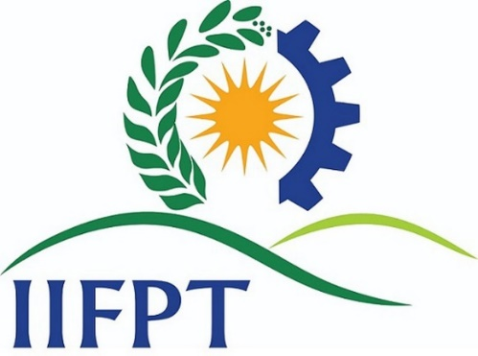

Contact Us
Director,
Indian Institute of Food Processing Technology (IIFPT)
(Ministry of food processing industries, Government of India)
Pudukkottai Road, Thanjavur 613005, Tamil Nadu.
Phone No: +91-4362-228155, Fax No: +91 4362 227971
Email: director@iifpt.edu.in Website:www.iifpt.edu.in



